Steven Peralta, Chris Cao, Daniel Mesones

4/25/24

CSE4500

Group 7 Baceline Reading

**Screenshots of members’ websites located in README**

**User Presence Times:**

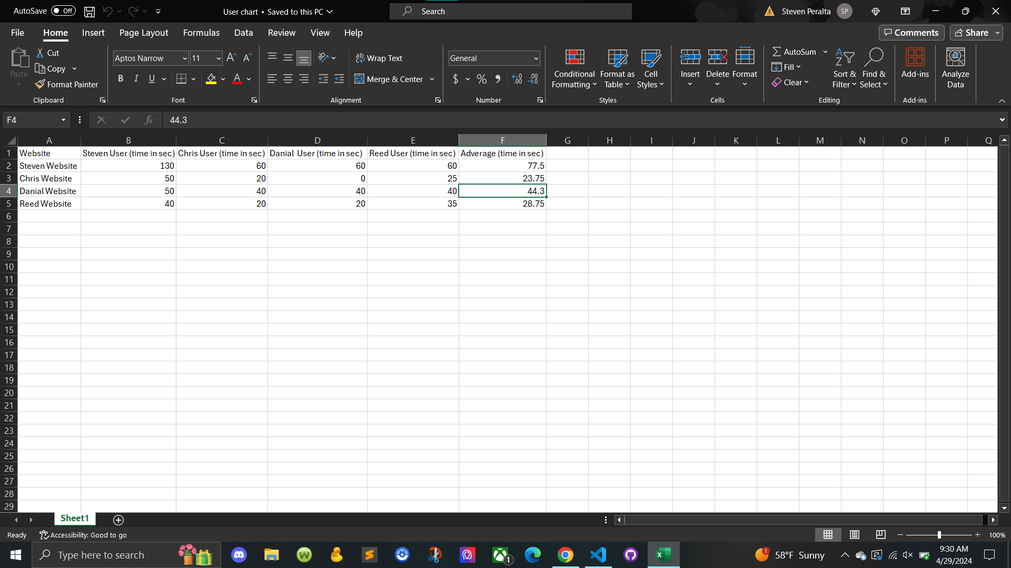

**Final Project Github Link:**

<https://github.com/DracoInferno/Cse4500FinalProject>

**Selected Website Explanation:**

We chose Steven’s website because he had the highest average presence time of 77.5 seconds. Steven had the most images in his website which all of our unique users recognized. Based on this, we formed a hypothesis centering around images.

**Final/Collective Hypothesis:**

**We believe** adding more images and links to our website

**Will** attract more users and will increase overall presence time the most effectively

**Because** images and links provide a more visually appealing experience for the user and will successfully retain users’ interest in our website and also gives the user a sense of exploration to further browse the web page.

**Brainstorming Process:**

**Hypothesis 1: (Christopher Cao)**

**I believe** adding more images to our website

**Will** then attract more users to the website and will increase overall presence time for all users

**Because** images capture the attention of users more effectively than links and keywords and will motivate users to view any additional information the website has to offer.

**Hypothesis 2: (Daniel Mesones)**

**I believe having a visually appealing website, such as a variety of images, colors, and font variations will increase presence time and attract a greater amount of users because the eye will easily grasp on to bright colors and will want to go explore every unique detail compared to a website with neutral colors, little visual imagery, and standard font sizes.**

**Hypothesis 3: (Steven Peralta)**

**I believe that adding more images and more links**

**Will add more presence time to our website**

**Because with more images it will make it more visually appealing to eyes and the links could take the user to things they might like because we might have the same interest.**

**Hypothesis 4: (**Reed Stallman**)**

**I believe** adding more images

**Will** increase user retention

**Because** more images means more things to look at